1668 N. Alpine Road~ Rockford ~ IL ~ 61107 ~ 815-395-6460
skaiser@greatharvest.com ~ www.rockfordgreatharvest.com
Fill this out and email, mail, or bring to the store.
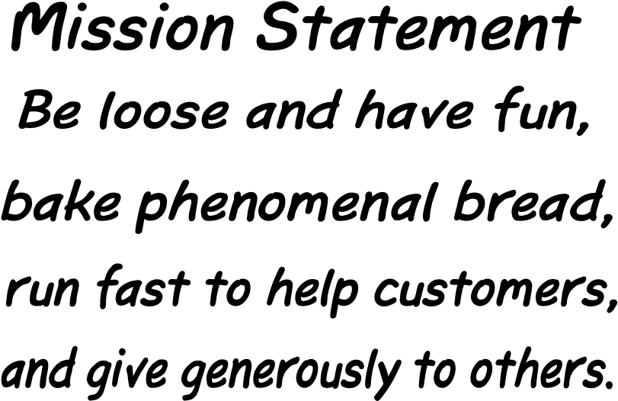 | The people who make up Great Harvest are the foundation upon which the ultimate success of our business rests.  Above and beyond all else, working at Great Harvest means making a serious commitment to learning about great food and great service; to helping create an exceptional workplace. We understand that not everyone will care as much about these things as we do; if Great Harvest isn’t for you, we wish you the best. If you think this is the spot you’ve been looking for, then go right ahead and keep filling out this application COMPLETELY. If we like what we see, we’ll contact you within 7—10 business days for an interview.  Steve and Barb
- Please print:
Are you a U.S. citizen? Yes  Are you at least 18 years of age? | No | If not, what type of visa do you hold?_________________
- Please list your educational information (schools attended, year completed, degrees/major).
- Where have you worked? (include dates, type of position, company, phone number, reason for leaving, etc.) Feel free to attach additional paper or use the back of this sheet.

- List 2 best references, how you know them, and their phone numbers. Please don’t submit this application without working phone numbers. These should be a former employer, teacher, or somebody else you worked for—not a relative or friend.
- Availability to work—full time or part time? Are you available early mornings, Saturdays and holidays? Would you be willing to be “on-call” for last minute hours? If part time, list days and hours available.
- What is your desired rate of pay and desired hours/week (minimum hrs needed and max desired)?
- Great Harvest is a high-volume business with a work day that can be long and stress-filled.
What makes you believe that you can perform well and excel under these working conditions?
- Great Harvest is a service-oriented business. What does good service mean to you?
- Tell us about any of your special or unique skills that may be useful at Great Harvest.
- What do you like to do in your spare time?
I hereby affirm that the information provided on this application (and attached resume, if any) is true to the best of my knowledge. I also agree that falsifying information or significant omissions may disqualify me from further consideration for employment and may be considered justification for dismissal if discovered at a later date.

Signature: ________________________________ Date: _____________

